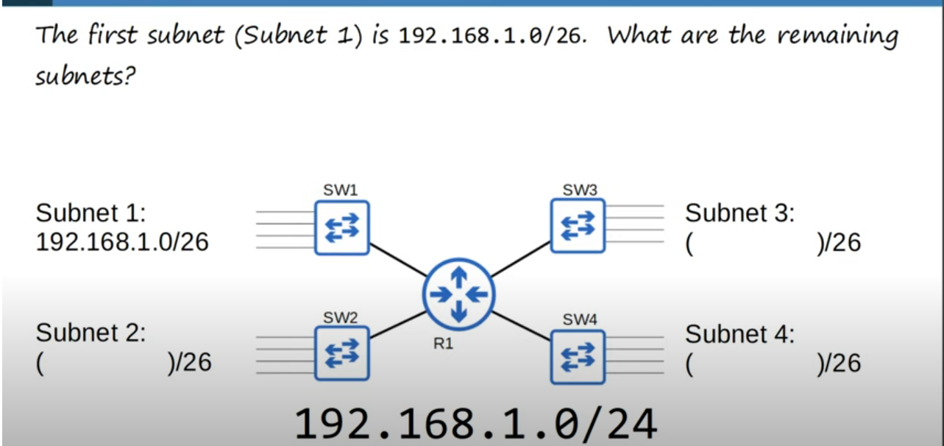
Finding 4 subnets for previous video example network

Note: To find next subnets we add 1 to previous network’s broadcast address.Below is how we find out subnet2.

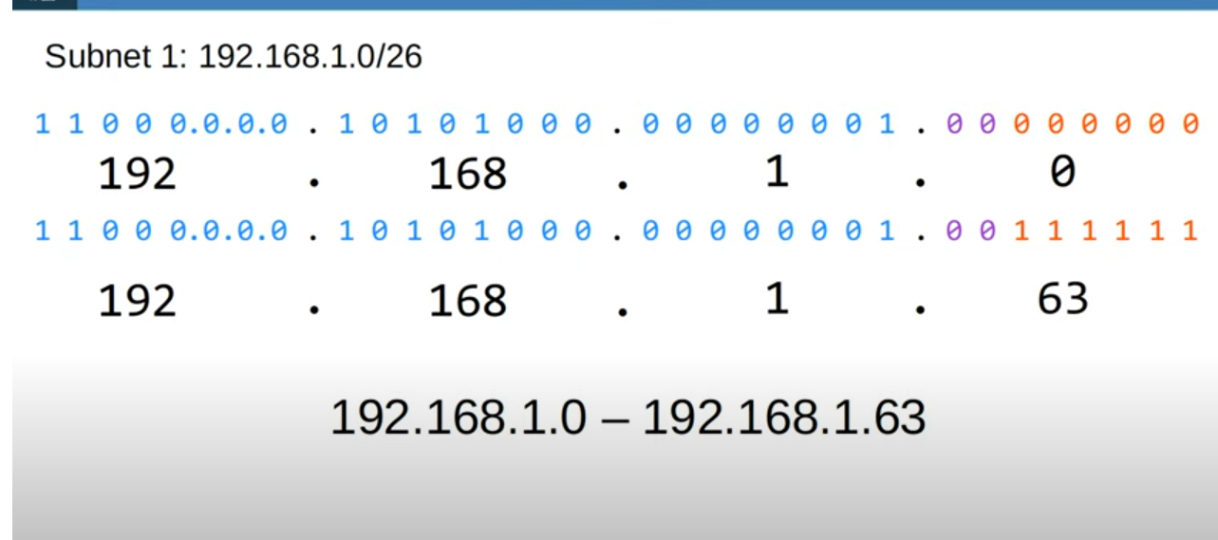
Subnet 1
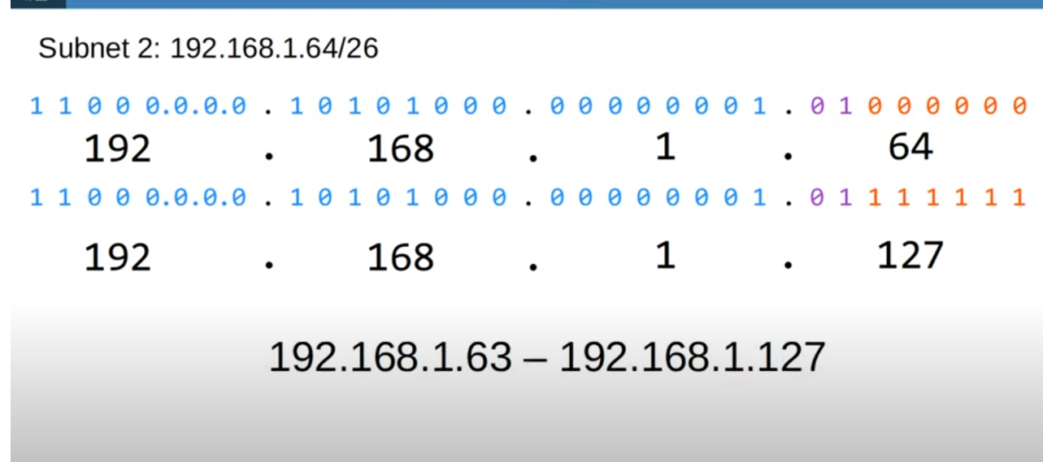
Subnet 2 network address and range

Note: So to find out subnet 2 network address we add 1 to broadcast address of Subnet 1(192.168.1.63).
So the subnet2’s address will be 192.168.1 64/26.This way we find out other subnet’s addresses

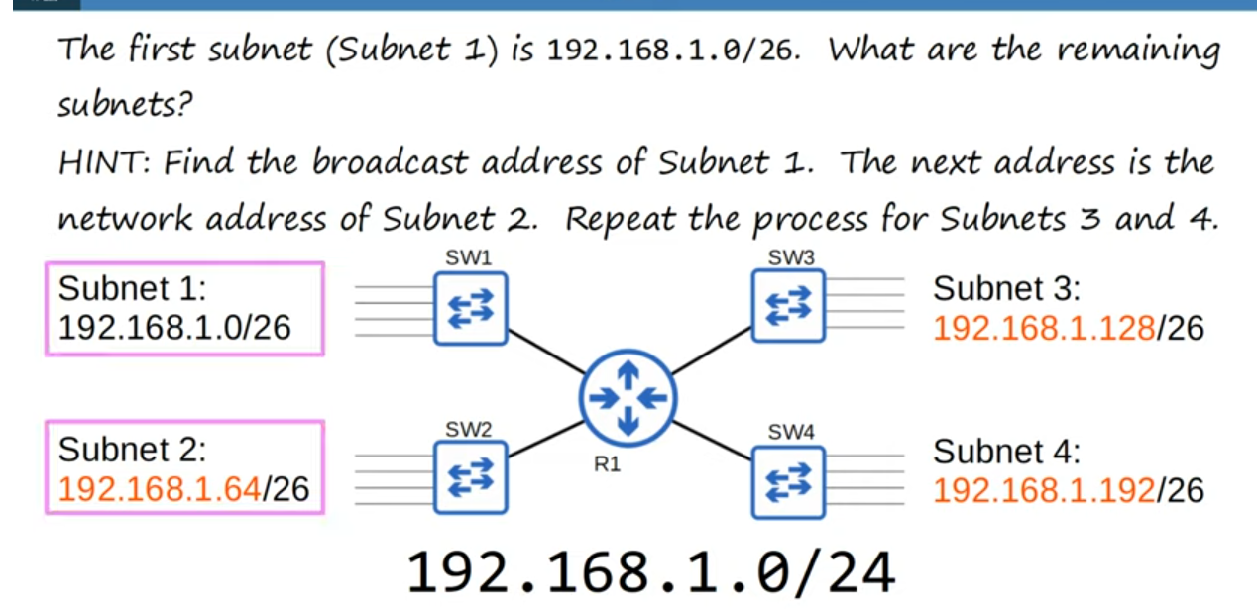
Final result(All subnets with their addresses)

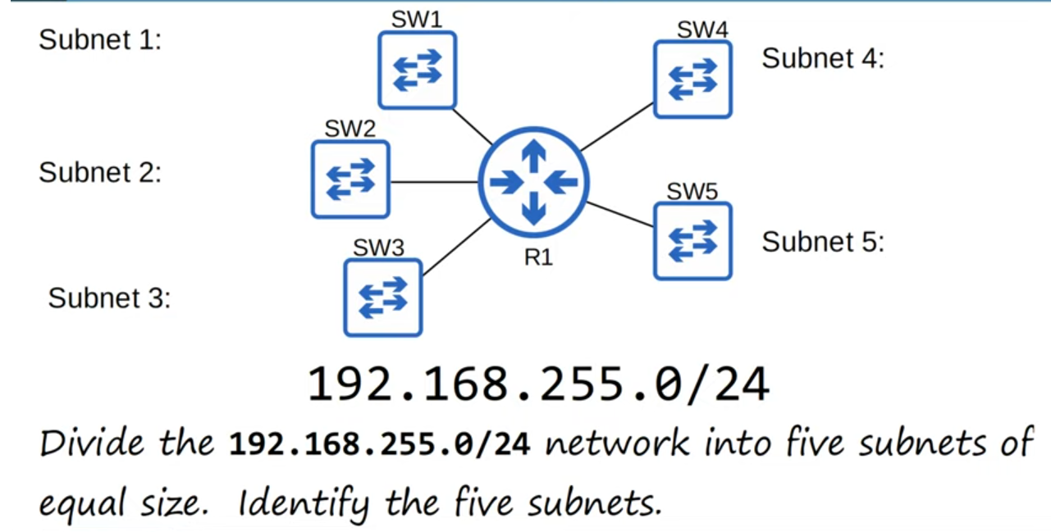
Another problem

Note:In this case number of hosts in each subnet is not specified.So we make 5 subnets that are as large as they can be.
Note: All we have to do to solve this problem is find how many bits can we borrow from the host portion.

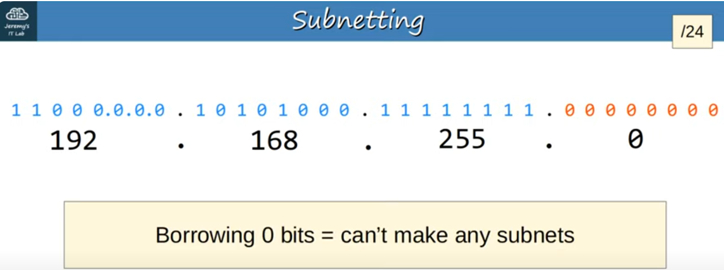
Borrowing 0 bits
Note: When we borrow 0 bits from host portion,we can’t make any subnets.We just have one network(192.168.255.0/24).
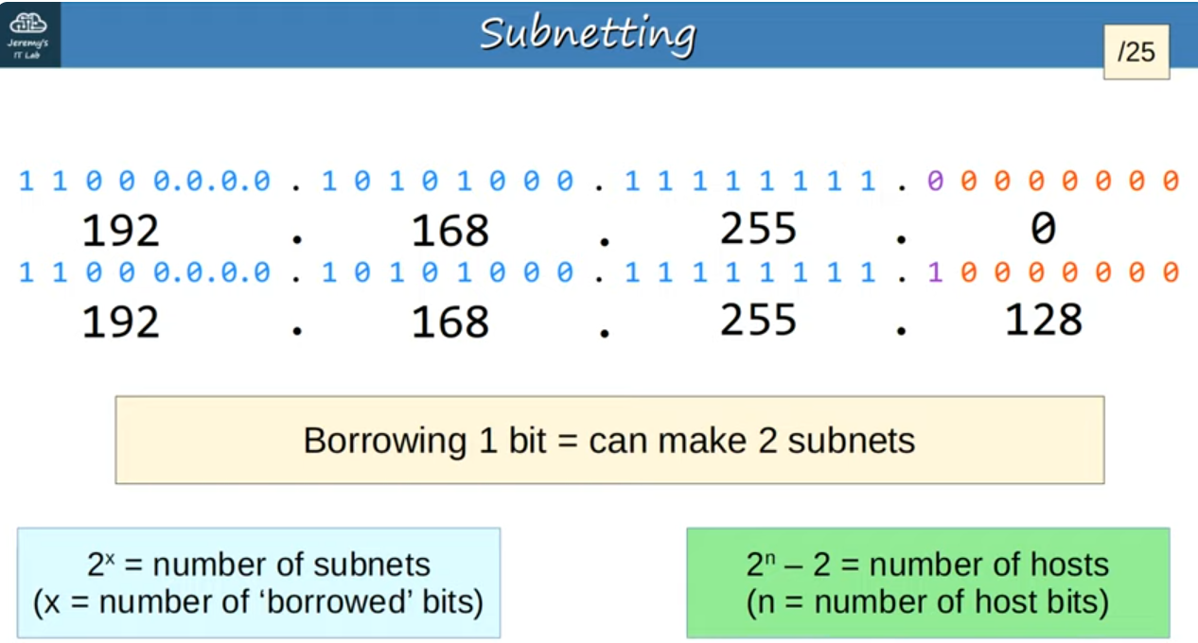
Borrowing 1 bit
Note: Borrowing 1 bit,we can make 2 subnets,because all of the original blue bits cannot change(that is the network we received),however the purple bit borrowed from the host portion we can change,and it can be either 0 or 1,if it’s 0 then we have 192.168.255.0/25 network,and if it’s 1, it is 192.168.255.128/25 network

Note: The formula for the number of subnets and formula for the number of hosts are in blue and green
Note: Borrowing 1 bit we can make 2 subnets,but we need 5 subnets,so borrowing 1 bit isn’t enough.

Solution: When we borrow 3 bits, we can make 8 subnets,so that is enough.Here is the final network.
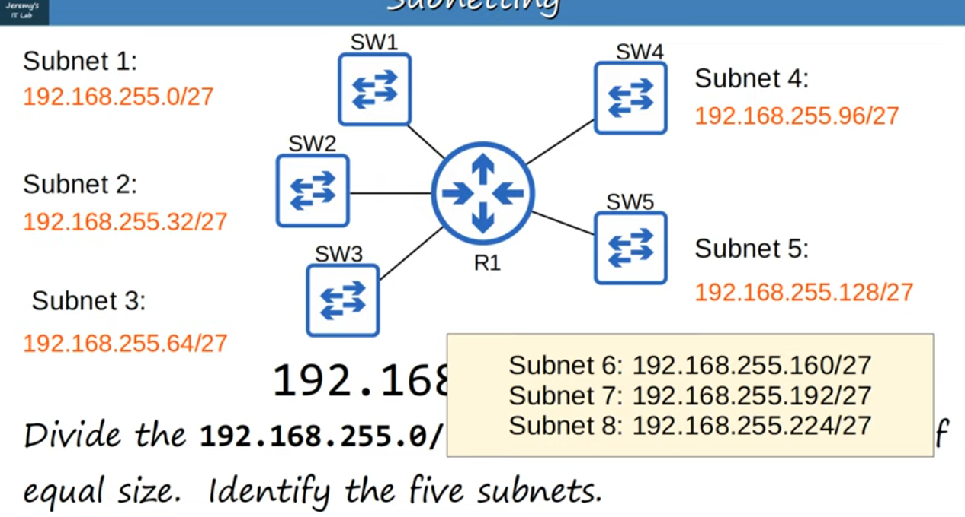
Final subnets with their addresses
Note: In yellow box there are subnets that are not used.
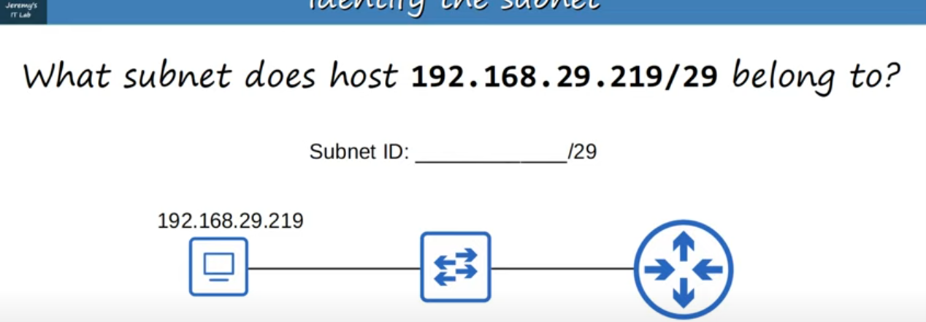
Problem to find the subnet

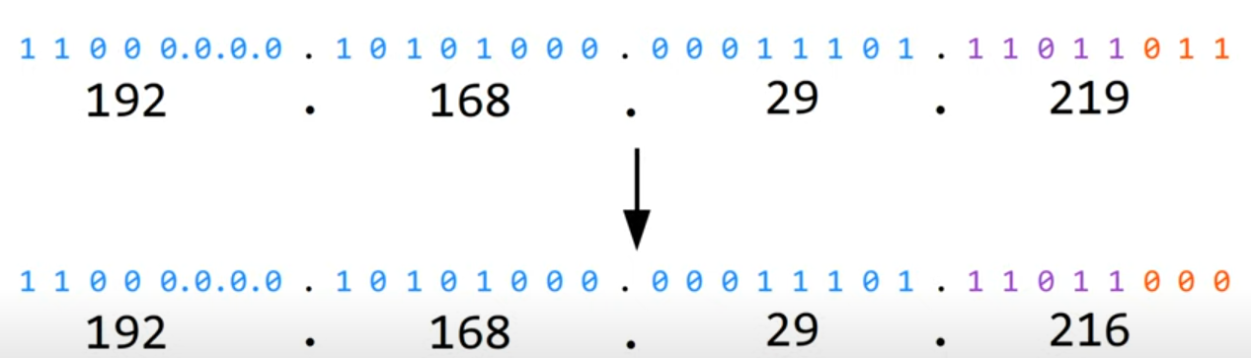
Solution of the problem above

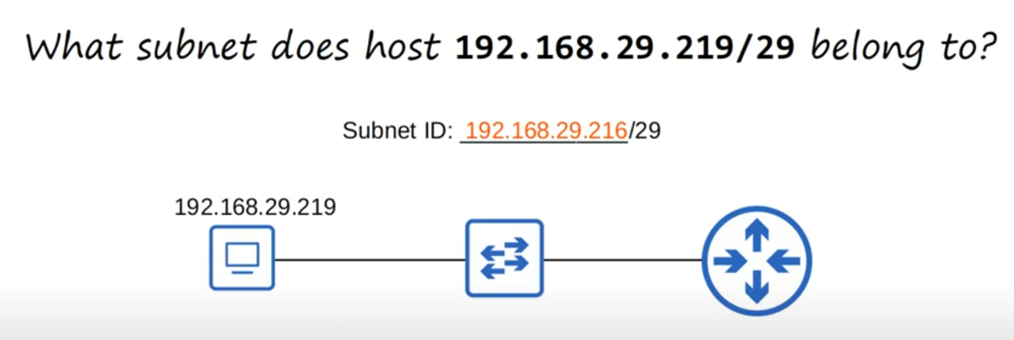
Answer to the problem

